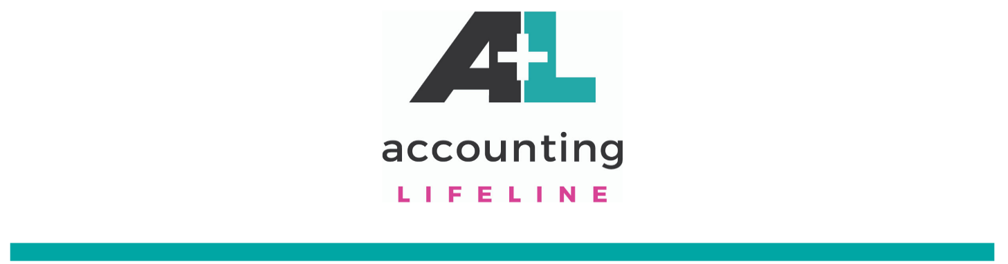

COVID-19
Due to the COVID-19 concerns, we want to assure you that as a cloud accounting firm, our team is safe and able to stay devoted to you. As you grasp what changes you need to make for your business, please reach out if there are additional resources you need.

One way we can help is by training your staff to be a remote workforce.
By utilizing technologies, you can enable your teams to work safely from their own home offices, which can make all the differences in your ability to sustain your business during this unexpected crisis. We also offer cloud training on technologies for streamlining the systems in your day to day operations.

Another way we can help is stepping in as your bookkeeping/accounting department during transition. We regularly offer remote bookkeeping and accounting services on weekly and monthly basis to assure accuracy of your small business QuickBooks. Reach out to learn more.

Each month we offer a Free RoundTable Meeting in which we discuss relevant business topics. This upcoming meeting will cover this very topic of how to utilize apps to create efficiency. Next week on Wednesday, we will host a special edition of our Roundtable, which will cover how to create a remote workforce.
Register here for the upcoming webinar.

During the months ahead, please reach out with any needs you may have.
Click here to schedule a meeting.

Supporting local business,
Liz Scott

Free Resources:
COVID Protecting your Employees and Business
Right Networks QuickBooks Hosting Solutions
QuickBooks Online Trial
Free Zoom Conferencing
Internet Bandwidth Guidelines

